**Montre ce que tu sais en**  **math 3ème année**

**mercredi** Sais-tu comment faire 10?

1. 4 + ____ = 10 2.) ____+ 8 = 10 3.) 1 + ____ = 10 4.) ____ + 6 = 10
2. 10 +____ = 10 6.) ____ + 9 = _____ 7.) 2 + ____ = 8 8.) ____+ 7 = 10
3. ____ + 3 = 10 10. ) 5 + ____ = 10

Parents: Your child should know these facts without hesitation. Please you’re your practice these regularly if they aren’t known instantly.

**lundi Parents: Please listen as your child completes the following tasks:**

Parents: Please encourage your child to do this counting without the use of the chart.

1. Commence à 12. Compte par 10 jusqu’à 102.
2. Commence à 95. Compte à rebours par 1 jusqu’à 15.
3. Commence à 94. Compte à rebours par 10 jusqu’à 4.
4. Commence à 13. Compte par 2 jusqu’à 81.

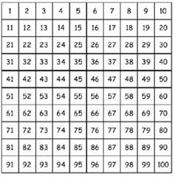

**mardi** Compte la monnaie.

1. 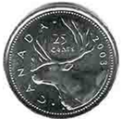 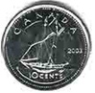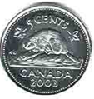 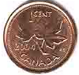_________
2.   __________

**jeudi : Compte quelque chose. _________________________________________**



Child’s Assessment Parent’s Assessment

This week’s homework was: This week’s homework for my child was:

* Quite easy Quite easy
* A good challenge A good challenge
* Pretty difficult Pretty difficult

Comments: ­­­­­­­­­­­­­­­­­­____________________________________________________________________________

_______________________________________________________________________________________