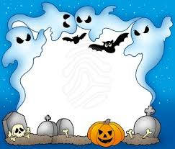

Halloween Activity Day
On Wednesday October 31th we will be
having a Halloween “celebration” complete with crafts, fun Math and Language Arts games!
*Please do not send in any treats. (I will have some “goodies” for the children.)
If you are free to volunteer in the classroom that morning from 10:00am until 12:00pm please let me know.
Thank you!!

